Hello,

Our group of 5 – **Iveta, Kusuma, Margo, Bricia and Denis** would like to present you with a detailed explanation of our project. Name of the project – **Find a Junior / Find Your Junior**.

**Description** : Helping companies to find their Junior Web Developer.

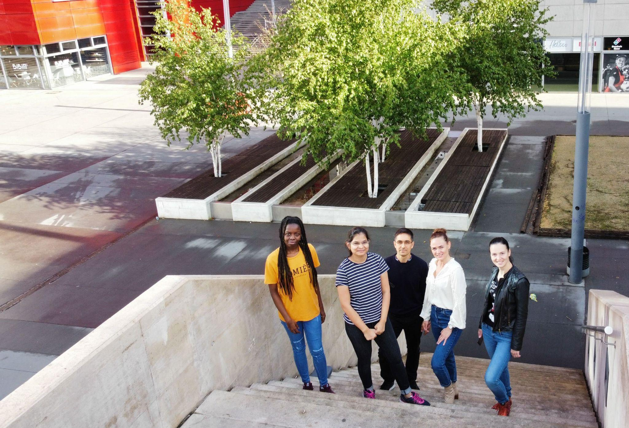

At the bottom, you can find a link that leads to a schema of the logic used for the choices made by the users (employers/jobseekers), once they reach our website.

Depending on who is using the website, different features will be implemented.

Firstly, I will explain the features available for companies. One main feature of our website is going to be a search feature that allows users to filter profiles by specific keywords (programming languages, frontend, backend, level of knowledge).

We also want to implement a feature where an interested employer can contact a junior developer and request that a soft skills/personality test is completed. At this stage they can only ask for a test and are not able to directly message potential candidates. Candidates can refuse or accept to take the test although there are no negative downsides to it. Once the test is completed, the employer receives a notification (another feature) and they can refuse to continue contact if no longer interested.

If they want to hire the candidate then, they can now directly contact the candidate.

Now, I’ll detail the user-related features.

The main feature will be the registration/login process. First-time users will have to register before they can access the website. They will also upload a CV during the registration process. We will store the credentials given in by the user in the database and check them during the login process. Users can now log into the website.

They will be encouraged to complete a form which will be used to build a ‘user profile’. This user profile is what employers will see and since it is necessary, juniors will have restricted access to the website until it is completed. That way, there will be no incomplete profiles due to users not completing the form. Incomplete profiles will not be shown in the search results.

Additionally, users will be asked to complete a questionnaire about hard skills. They will complete a soft skills test upon demand. If they pass, they will be able to exchange messages with an employer.

Overall, the application should facilitate the employment of junior web developers and increase the accuracy between the researched profile and the person hired at the end. Our website fulfils the needs of companies who are specifically looking for a junior web developer and not a ‘junior’ with 5 years of experience in all of the latest technologies.

Regards,

Our Team

Schema User Logic : <https://drive.google.com/file/d/1baqeYbwREzPS3MVfJiIE5qGmgJ6N_5Hi/view?usp=drivesdk>